**Chapter 7**

**Testing**

A.S.C.A.D. is a software tool that deals in a medical context, and hence must include minimal errors. To achieve such accuracy, the software needs to be tested well.

Software testing is a process of executing a program or application with the intent of finding software bugs. In other words, testing is executing a system in order to identify any gaps, errors, or missing requirements in contrary to the actual requirements.

**7.1 Test cases**

|  |  |  |  |
| --- | --- | --- | --- |
| **Test Case** | **Expected Result** | **Actual Outcome** | **Result** |
| Blank patient name | Error : Please enter the Patient name. | Error : Please enter the Patient name. | Success |
| Blank patient age | Error : Please enter the age of the patient. | Error : Please enter the age of the patient. | Success |
| Invalid patient age | Error : Please enter a valid age of the patient. | Error : Please enter a valid age of the patient. | Success |
| Blank doctor name | Error : Please enter the name of the doctor or medical practitioner who advised the test. Enter N.A. in case of self test. | Error : Please enter the name of the doctor or medical practitioner who advised the test. Enter N.A. in case of self test. | Success |
| Blank image path | Error : Image path empty. Please browse to the input image. | Error : Image path empty. Please browse to the input image. | Success |
| Trying to enter an invalid image path. | The user must only be allowed to enter a legal path. | The text box to enter the path to the input image is disabled. As a result, the user has to browse to the image using the ‘Browse’ button. | Success |

Table 7.1.1. Test case table

**7.2 Type of testing used**

Black box testing:

Black-box testing is a method of software testing that examines the functionality of an application without peering into its internal structures or workings. This method of test can be applied to virtually every level of software testing: unit, integration, system, functional and acceptance.

* Functional testing

Functional testing is a quality assurance (QA) process and a type of black box testing that bases its test cases on the specifications of the software component under test. Functions are tested by feeding them input and examining the output, and internal program structure is not considered.  Functional testing tests a slice of functionality of the whole system.

Test cases:

1. Blank patient name

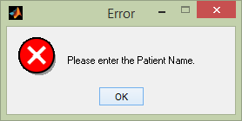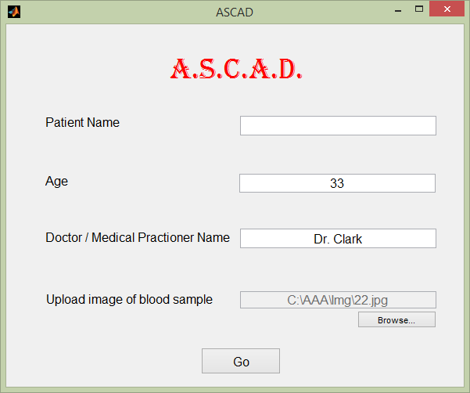

Fig. 7.2.1. Testing : Blank patient name

1. Blank patient age

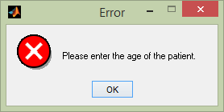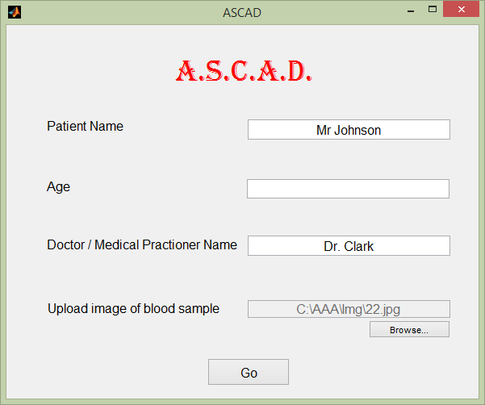

Fig. 7.2.2. Testing : Blank patient age

1. Invalid patient age

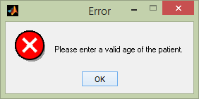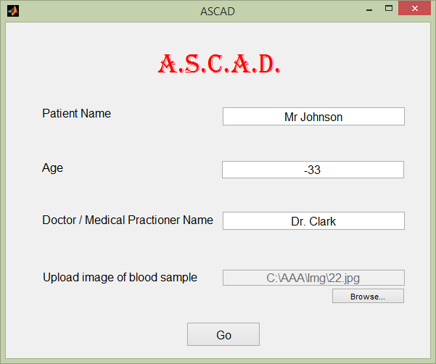

Fig. 7.2.3. Testing : Invalid patient age

1. Blank doctor name

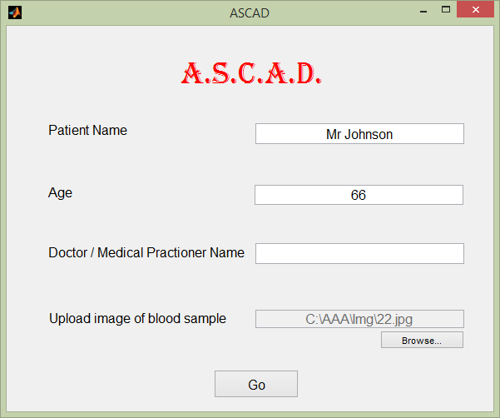

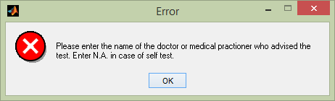

Fig. 7.2.4. Testing : Blank doctor name

1. Blank image path

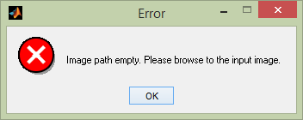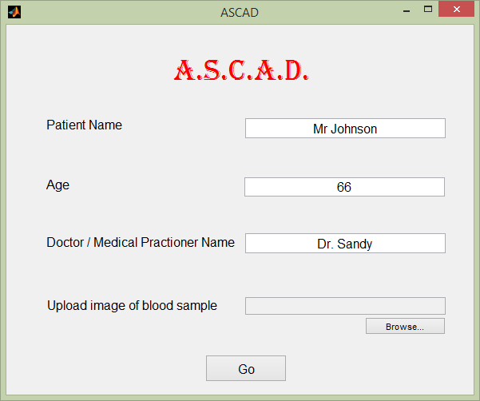

Fig. 7.2.5. Testing : Blank image path

1. Trying to enter an invalid image path.

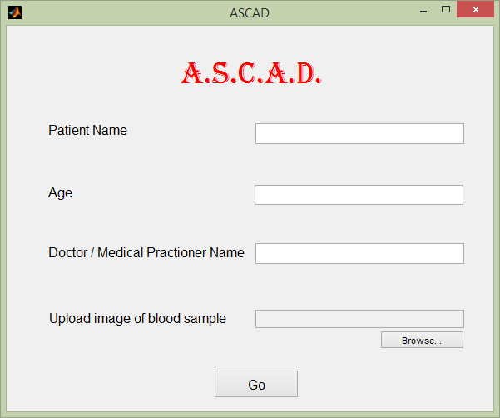

Fig. 7.2.6. Testing : Trying to enter an invalid image path